CELL BIOLOGY

NUCLEUS

-Dr Shankar

objectives

1) explain how DNA is packaged into chromatin, and chromatin into chromosomes. Know what telomeres, centromeres, kinetochores, and origins of replication are.
2) describe the general features of nuclear structure (nuclear envelope, nuclear pore complex (NPC), nuclear lamina, heterochromatin, euchromatin, and nucleoli). Know the function of each.
3) recognize these nuclear structures at the light and/or EM level
4) understand why protein trafficking signals are needed in the cell, and what they consist of.
5) explain the role of NLSs and NESs, the NPC, importins , exportins, and Ran in nuclear transport.
6) list the roles of the three major types of RNA, and where in the nucleus each is transcribed.
7) explain how a ribosome is assembled.

THE NUCLEUS
Contain the code for all of a cell’s enzymes and other proteins, the nucleus is the command center of the cell
The nucleus also contains the molecular machinery to replicate the DNA and to synthesize and process all types of RNA
COMPONENTS OF THE NUCLEUS -
- Nucleolus: Largest structure within a cell
- Nuclear envelope containing chromatin, the mass of DNA and its associated proteins, with one or more specialized regions of chromatin called nucleoli
- Nuclear Envelope - selectively permeable barrier between the nuclear and cytoplasmic compartments
- 2 layers separated by perinuclear space
- perinuclear space continuous with the extensive cytoplasmic network of the rough endoplasmic reticulum (RER)
- This space and the outer nuclear membrane are continuous with the extensive cytoplasmic network of the rough endoplasmic reticulum
- Inner nuclear envelope ass. With nuclear lamina – has lamins ; intermediate filament (progeria)
- Nucleoporins: 3000-4000
- out of the nucleus include ribosomal subunits and other RNAs associated with proteins, while inbound traffic consists of chromatin proteins, ribosomal proteins, transcription factors, and enzymes
- Energy for the transport is derived from guanosine 5′-triphosphate (GTP)

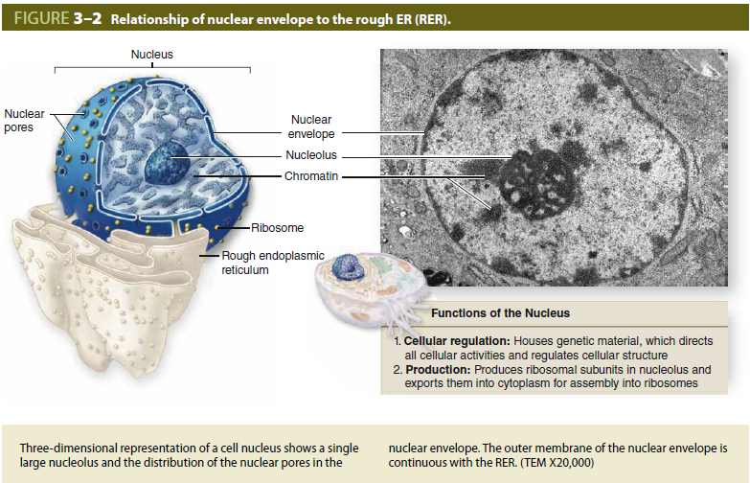
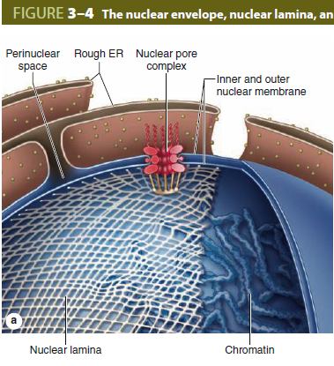

Chromatin
- DNA and all of the associated proteins involved in the organization and function of DNA
- each cell’s chromatin (except that of eggs and sperm) is divided among 46 chromosomes (23 pairs)
- identical chromatin units called chromatids
- DNA of each human cell is approximately 2 m long, with 3.2 billion base pairs
- DNA associating with sets of small basic proteins called histones
- The structural unit of DNA and histones is called the nucleosome which has a core of eight histones (two copies each of histones H2A, H2B, H3, and H4)
- Series of nucleosome- beads on a string
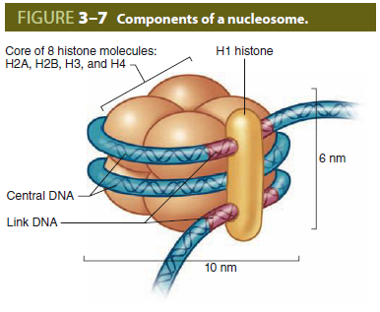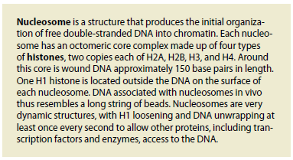
- two categories of chromatin: Euchromatin finely dispersed granular material
- Heterochromatin (Gr. heteros, other + chroma, color) appears as coarse, electron-dense material
- Euchromatin is rich with genes
- Heterochromatin shows little or no transcriptional activity- constitutive and facultative heterochromatin
- Constitutive heterochromatin is generally similar in all cell types and contains mainly repetitive, gene-poor DNA sequences, including the large chromosomal regions called centromeres and telomeres, which are located near the middle (most often) and at the ends of chromosomes respectively
- Facultative heterochromatin contains other regions of DNA with genes where transcription is variably inactivated in different cells by epigenetic mechanisms
- Euchromatin predominates in active cells such as large neurons, while heterochromatin is more abundant in cells with little synthetic activity such as circulating lymphocytes.
- Facultative heterochromatin also occurs in the small, dense “sex chromatin” or Barr body which is one of the two large X chromosomes present in human females but not males
- Cells of males have one X chromosome and one Y chromosome; like the other chromosomes, the single X chromosome remains largely euchromatic
- The X and Y sex chromosomes contain genes determining whether an individual will develop as a female or a male
- In addition to the pair of sex chromosomes, cells contain 22 pairs of autosomes
- Each pair contains one chromosome originally derived from the mother and one from the father
- The members of each chromosomal pair are called homologous because, although from different parents, they contain forms (alleles) of the same genes
- Cells of most tissues (somatic cells) are considered diploid because they contain these pairs of chromosomes
- Sperm cells and mature oocytes (germ cells) are haploid, with half the diploid number of chromosomes, each pair having been separated during meiosis
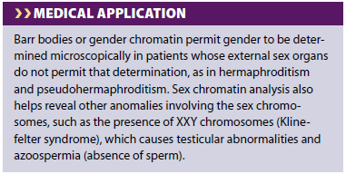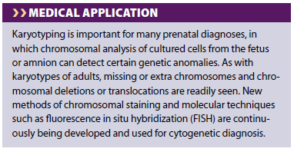
Microscopic analysis of chromosomes usually begins with cultured cells arrested in mitotic metaphase by colchicine or other compounds that disrupt microtubules.
After processing and staining the cells, the condensed chromosomes of one nucleus are photographed by light microscopy and rearranged digitally to produce a karyotype in which stained chromosomes can be analyzed
Nucleolus
- spherical, highly basophilic subdomain of nuclei in cells actively engaged in protein synthesis
- Densely concentrated ribosomal RNA (rRNA) that is transcribed, processed, and assembled into ribosomal subunits
- Chromosomal regions with the genes for rRNA organize one or more nucleoli in cells requiring intense ribosome production for protein synthesis during growth or secretion
- Molecules of rRNA are processed in the nucleolus and very quickly associate with the ribosomal proteins imported from the cytoplasm via nuclear pores.
- The newly organized small and large ribosomal subunits are then exported back to the cytoplasm through those same nuclear pores
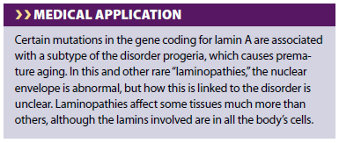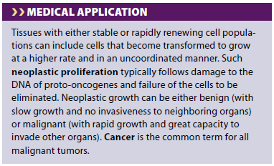

CELL CYCLE
Objective –
- list the stages of the mitotic cell cycle, and what happens
- in each stage. Be able to recognize these stages in cells at
- the EM and light microscopic level.
- recite the DNA content (ex. 2x, 4x) and chromosome
- number during the different stages of mitosis
- list the functions of each of the three cytoskeletal filament
- networks (actin, MTs, and IFs) during mitosis.
- explain the functions of cohesins and condensins
- explain why taxol (an anti-microtubule drug) is used as an
- anti-cancer agent
- explain the basic differences between necrosis and apoptosis. Be able to list both differences in the dying cell's appearance, intracellular changes that occur, and the effects of this cell’s death on the organism.
THE CELL CYCLE
- Before differentiation, most cells undergo repeated cycles of macromolecular synthesis (growth) and division (mitosis)
- The regular sequence of events that produce new cells is termed the cell cycle
- The cell cycle has four distinct phases: mitosis and periods termed G1, S & G2
- G1: the time gap between mitosis and the beginning of DNA replication; active RNA and protein synthesis, including proteins controlling progress through the cell cycle. the cell volume, reduced by half during mitosis, returns to its previous size
- S: the period of DNA synthesis. Histone synthesis, and the beginning of centrosome duplication
- G2: the gap between DNA duplication and the next mitosis. proteins required for mitosis accumulate
- G0 phase: cell cycle activities may be temporarily or permanently suspended
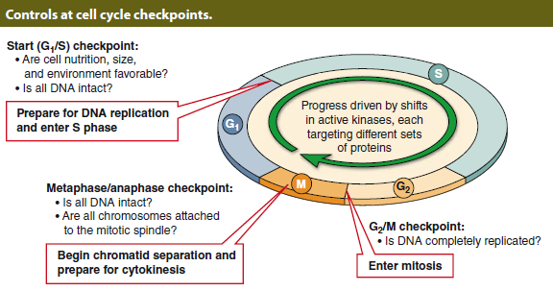
- Cell cycling is activated in postmitotic G0 cells by protein signals from the extracellular environment called mitogens or growth factors that bind to cell surface receptors and trigger a cascade of kinase signaling in the cells
- Cyclins activate cyclin dependant kinases (CDK’s)
- CDK’s phosphorylate enzymes/ transcription factors reqd for that phase of cell cycle
- Removed from cell after ubiquination by proteasomes
- Cell cycle is halted by inadequate nutrition, DNA damage- G1 restriction point
- If the problem at any checkpoint cannot be corrected, proteins encoded by tumor suppressor genes are activated and that cell’s activity is redirected toward cell suicide or apoptosis
- DNA changes (mutations) resulting from damage are not always detected and corrected (or eliminated)
- If such a change occurs in a gene important for cell cycle activities, such as genes for certain growth factors, their receptors or signaling kinases, normal controls on the cell cycle may be affected and growth may occur in a less-regulated manner usually detected by the tumor suppressor proteins such as p53.
- Failure to detect unregulated cell cycling can lead to additional defects and the cellular changes found in the various types of cancer.
- In many forms of human cancer, the gene for the key tumor suppressor p53 is itself mutated, thus reducing the ability to eliminate cells with damaged DNA and facilitating proliferation of cells with new genetic defects
MITOSIS
- Cell division
- Only cell cycle phase that can be routinely distinguished with the light microscope
- A parent cell divides and each of the two daughter cells receives a chromosomal set identical to that of the parent cell
- The chromosomes replicated during the preceding S phase are distributed to the daughter cells
- The long period between mitoses (the G1, S, and G2 phases) is also commonly called interphase
- Prophase, metaphase, anaphase, telophase (IPMAT)
- prophase
- Nucleolus disappears
- Replicated chromatin condenses into discrete threadlike chromosomes, each consisting of duplicate sister chromatids joined at the centromere.
- The two centrosomes with their now-duplicated centrioles separate and migrate to opposite poles of the cell and organize the microtubules of the mitotic spindle.
- Late in prophase, lamins and inner nuclear membrane are phosphorylated, causing the nuclear lamina and nuclear pore complexes to disassemble and disperse in cytoplasmic membrane vesicles.

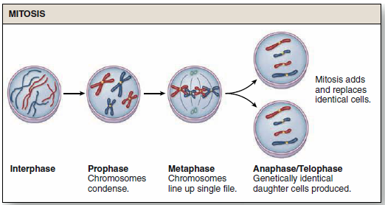
- METAPHASE - Chromosomes condense further and protein complexes called kinetochores (Gr. kinetos, moving) at each centromere attach to the mitotic spindle. The cell is now more spherical and the chromosomes are moved into alignment at the equatorial plate.
- anaphase - Sister chromatids (now called chromosomes themselves) separate and move toward opposite spindle poles by a combination of microtubule motor proteins and dynamic changes in the lengths of the microtubules as the spindle poles move farther apart
- telophase
- The two sets of chromosomes are at the spindle poles and begin reverting to their decondensed state.
- The spindle depolymerizes and the nuclear envelope begins to reassemble around each set of daughter chromosomes.
- A belt-like contractile ring of actin filaments associated with myosins develops in the cortical cytoplasm at the cell’s equator
- During cytokinesis at the end of telophase, constriction of this ring produces a cleavage furrow and progresses until the cytoplasm and its organelles are divided into two daughter cells, each with one nucleus
- Most tissues undergo cell turnover with slow cell division and cell death
- Nerve tissue and cardiac muscle are exceptions because their differentiated cells cannot undergo mitosis
- The cell turnover rate is rapid in the epithelium lining the digestive tract and uterus or covering the skin.

STEM CELLS & TISSUE RENEWAL
- Stem cells- small population of undifferentiated cells whose cycling serves to renew the differentiated cells of tissues as needed
- Divide infrequently; asymmetric
- One daughter cell remains as a stem cell while the other becomes committed to a path that leads to differentiation
- Stem cells of many tissues are found in specific locations or niches
- Stem cells are best studied in tissues with rapidly renewing cell populations, including blood cells, skin cells, and cells lining the digestive tract
- Most mitotic cells here are not stem cells but the more rapidly dividing progeny of the cells committed to differentiation
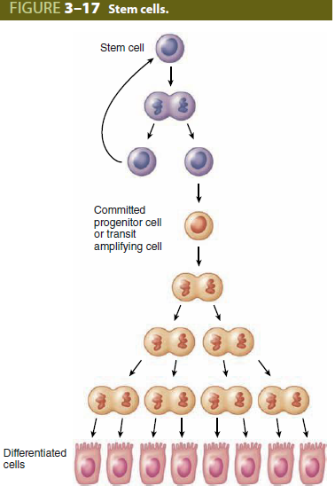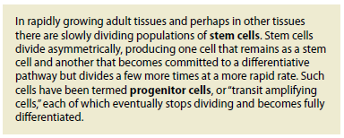
- They are commonly called progenitor cells or transit amplifying cells because they are in transit along the path from the stem cell niche to a differentiated state, while still amplifying by mitosis the number of new cells available for the differentiated tissue
- Cells formed by progenitor cells may become terminally differentiated, meaning that renewed cycling cannot occur and the specialized cells exist for only a short time.
- In tissues with stable cell populations, such as most connective tissues, smooth muscle, and the cells lining blood vessels, stem cells are not readily apparent and differentiated cells appear to undergo slow and episodic division to maintain
- tissue integrity.
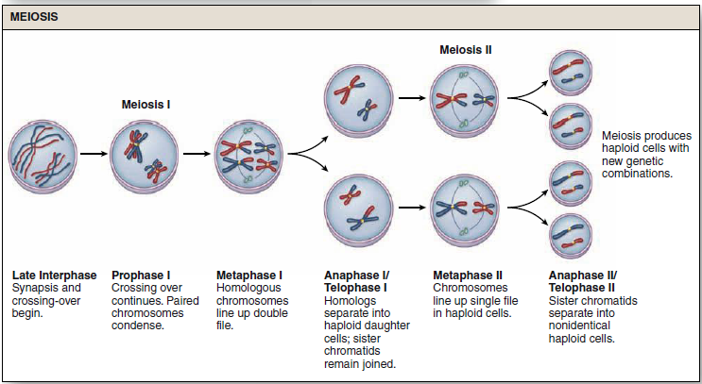
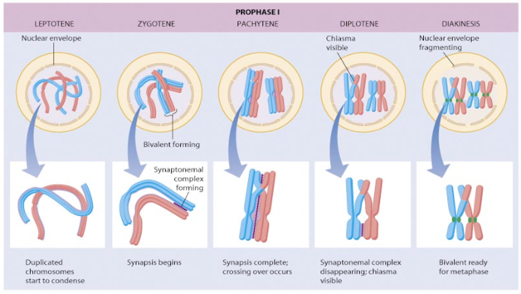

Meiosis -I
- Prophase of meiosis –I consists of five stages
1.Leptotene
2. Zygotene
3. Pachytene
4. Diplotene
5. Diakinesis
- LEPTOTENE
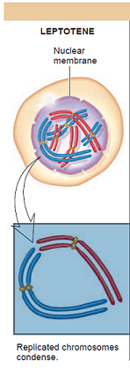
- Chromosomes begin to condense.
- Homologous chromosomes which were replicated in a preceeding S phase (4N DNA) locate one another with in the nucleus
- ZYGOTENE –
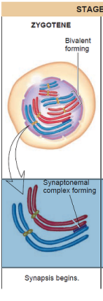
- Homologous chromosomes are arranged in pairs lengthwise.
- This process is called synapsis.
- One member of pair is maternal and other paternal
PACHYTENE
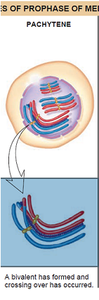
- Synapsis is complete for all chromosomes.
- Each bivalent looks like a single structure, but is actually two pairs of sister chromatids held together - tetrad
DIPLOTENE -
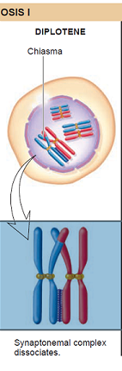
- Non-sister chromatids of a tetrad cross each other at one or more points forming chiasma.
- This phenomenan is known as cross-over, which permits a continual re-shuffling of genes, so that new and sometimes advantageous combinations may take place.
- This forms the structural basis of hereditary diversity between individuals coming from the same parentage
DIAKINESIS
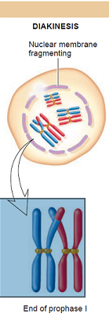
- Homologous centromeres pull apart and chromosomes are separated after uncoiling.
- Meanwhile the nuclear membrane and nucleolus disappears
- Metaphase –I: homologous pairs of chromosomes align in equatorial plane. The bodies attached to the spindle microtubules are bivalents, not single chromosomes
- Anaphase-I: centromeres do not divide. Homologous chromosomes separate from each other and migrate to opposite poles of spindle carrying their chromatids.
- Telophase –I: each of daughter cell presents half of the original number of chromosomes (haploid with 2N DNA). There is redistribution of genetic material due to cross-over. As position of bivalent chromosomes is random, assortment of maternal and paternal chromosomes in each telophase nucleus is also random.
- Meiosis -II
- Each of daughter cell of meiosis-I enters straight into metaphase-II, and chromosomes align in new equatorial planes of the spindle.
- DNA replication does not take place between first and second meiotic divisions.( difference between meiosis-II and mitosis)
- Anaphase-II: the centromeres divide, and the chromatids separate to form new chromosomes migrating to opposite poles of the spindle
- Telophase-II: four gametes are formed from two cells of first meiotic division, each with haploid number of chromosomes (1N DNA).
- This is associated with the synthesis of one polynucleotide strand to restore typical double-helix model of DNA molecule.

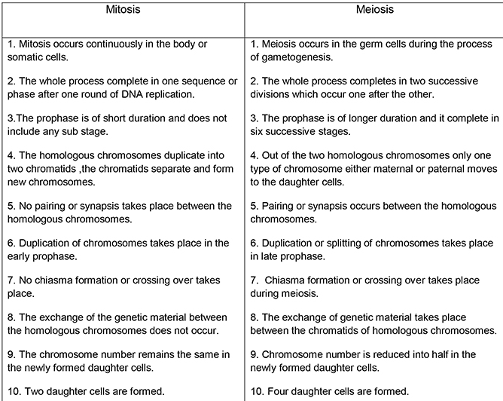
- Peculiarities of meiosis
- Crossing over permits a continual reshuffling of genes
- Centromeres do not divide in anaphase-I, culminates into reduction division of first meiosis with haploid number of chromosomes
- In Anaphase-II, centromeres divide and this maintains haploid number of chromosomes.
- Reduction division in meiosis is a necessity because the ovum is fertilized by sperm, the resulting zygote presents diploid number of chromosomes, which is constant for the species
- The whole process of meiosis can take years instead of hours
- Clinical applications
- Non-disjunction: during anaphase, after splitting of the centromeres, one or more chromosomes fail to migrate properly due to abnormal function of spindle apparatus.
- As a result both members of a particular pair go to one daughter cell which receives extra chromosome (trisomy) and other daughter cell deficient in that chromosome (monosomy).
- Errors in chromosomal segregation during meiosis-I leads to production of aneuploid progeny.
- (alterations in chromosomal number: diploid(2N), haploid(N), polyploidy (multiple of haploid other than diploid. Ex.3N, 4N), aneuploidy (chromosome number altered by one or more but not by multiples of haploid. Ex. N-1, N+1)
- Exposure to ionizing radiation promotes non-disjunction and may, by chromosomal damage, inhibits mitosis altogether
- In summary, meiosis and mitosis share many aspects of chromatin condensation and separation but differ in key ways:
- Mitosis is a cell division that produces two diploid cells.
- Meiosis involves two cell divisions and produces four haploid cells.
- During meiotic crossing over, new combinations of genes are produced and every haploid cell is genetically unique.
- Lacking synapsis and the opportunity for DNA recombination, mitosis yields two cells that are the same genetically.

APOPTOSIS
- Cell suicide (Gr. apo, off + ptosis, a falling)
- Rapid, highly regulated cellular activity that shrinks and eliminates defective and unneeded cells
- Results in small membrane-enclosed apoptotic bodies, which quickly undergo phagocytosis by neighboring cells or cells specialized for debris removal
- Apoptotic cells do not rupture and release none of their contents, unlike cells that die as a result of injury and undergo necrosis
- This difference is highly significant because release of cellular components triggers a local inflammatory reaction and immigration of leukocytes
- Such a response is avoided when cells are rapidly eliminated by apoptosis following cell cycle arrest or as part of normal organ development
- Apoptosis is controlled by cytoplasmic proteins in the Bcl-2 family, which regulate the release of death-promoting factors from mitochondria.
- Activated by either external signals or irreversible internal damage, specific Bcl-2 proteins induce a process with the following features:
1. Loss of mitochondrial function and caspase activation: Bcl-2 proteins associated with the outer mitochondrial membrane compromise membrane integrity, stopping normal activity and releasing cytochrome c into the cytoplasm where it activates proteolytic enzymes called caspases. The initial caspases activate a cascade of other caspases, resulting in protein degradation throughout the cell.
2. Fragmentation of DNA: Endonucleases are activated, which cleave DNA between nucleosomes into small fragments.
3. Shrinkage of nuclear and cell volumes: Destruction of the cytoskeleton and chromatin causes the cell to shrink quickly, producing small structures with dense, darkly stained pyknotic nuclei that may be identifiable with the light microscope
4. Cell membrane changes: “blebbing,” as membrane proteins are degraded and lipid mobility increases.
5. Formation and phagocytic removal: Membrane-bound remnants of cytoplasm and nucleus separate as very small apoptotic bodies
- Newly exposed phospholipids on these bodies induce their phagocytosis by neighboring cells or white blood cells.
- APOPTOSIS - EXAMPLES
1. In the ovary, apoptosis is the mechanism for both the monthly loss of luteal cells and the removal of excess oocytes and their follicles.
2. In embryos, shapes developing organs or body regions, such as the free spaces between embryonic fingers and toes.
3. Apoptosis of excess nerve cells plays an important role in the final development of the central nervous system.
4. Triggered by p53 and other tumor suppressor proteins, apoptosis is the method for eliminating cells whose survival is blocked by lack of nutrients or by damage caused by free radicals or radiation
- In all these examples apoptosis occurs very rapidly, in less time than required for mitosis, and the affected cells are removed without a trace.
